Code inspection & clean code
v2025-10-28
7 Code inspection & clean code 1
7.0 Introduction 1
7.1 Local analysis 1
7.2 Technical debt 3
7.3 Frontend inspection (performance, accessibility & best practices) 4
7.4 AI-assisted reviews 5

Introduction
Learning objectives
- Use static code analysis to inspect code quality, applying linters.
- Apply quality gates and quality dashboards to track code quality (using Sonar Qube)
Key points
- Static code quality can assess a code base to produce quality metrics. These metrics are based on the occurrence of known “bad smells” and weaknesses. In this kind of analysis, the solution is not deployed, nor is the code executed (thus the name static analysis).
- Static code analysis can be run locally using a “linter” (usually integrated in the IDE) but it would be even more import to implement code analysis in the team development infrastructure, i.e., at the continuous integration pipeline, using specialized services.
- Key code quality measures include occurrences of problematic code (“bugs” in logic/flow), vulnerabilities (security/reliability concerns), code smells (bad/poor practice or coding style); coverage (ratio tested/total); and code complexity.
- The estimated effort to correct the vulnerabilities is called the technical debt. Every software quality engineer needs tools to obtain realistic information on the technical debt.
Explore
- public projects on Sonar cloud that you can browse and learn.
- Webinar on static code analysis (promoted by Codacy)

Static analysis with SonarQube (local instance)
Static code analysis is typically integrated into the build cycle using a cloud service or a dedicated team server. In this lab we will use (containerized) SonarQube locally (SonarQube Cloud is the SaaS version).
- Prepare/copy a Maven-based Java project to analyze with SonarQube. The project should contain tests and the Jacoco plugin configured (in POM). You may reuse one from previous labs, for example, the meals booking app (from Lab 1.3)
- Prepare a local instance of SonarQube server (using the Docker image).
For this lab, you do not need to configure a production database (an embedded database is used by default).
Confirm that you can access the Sonar dashboard (default : http://127.0.0.1:9000) and change the default credentials (admin / admin).

- Complete the initial configuration to create a local project.
- Select “Create a local project”
- Give a name to the project and, next, choose a baseline method to detect changes (default “Use the global setting”).
- hit “Create project”.
- Now, let us configure the analysis settings.
- You should be in the “How do you want to analyze your repository?” page. If not, select Settings for the newly create project.
- Complete the Analysis method configuration. In step 1, set “Analysis method” to “Locally”.
- Next, generate an access token to be provided in client tools. Be sure to write it down (you will need it later).
- In step 2, chose Maven as the build tool. Copy the sample maven command generated for you. You will use this command to run the analysis from command line.
- In your project, lock the Sonar Maven plugin version in your POM, using an updated version.

Run the code analysis from Maven build (highlighted parts should be changed):
$ mvn clean install
$ mvn clean verify sonar:sonar -Dsonar.projectKey=eurom1 -Dsonar.projectName='myproj1' -Dsonar.host.url=http://127.0.0.1:9000 -Dsonar.token=sqp_487a32fdbab1f8ac2b37251294ea9d30000003

Note: alternatively, you can save part of the Sonar configuration as “global settings”, shortening the required maven command.

- Confirm that Sonar analysis was executed (check the log in the terminal). Access the SonarQube dashboard.
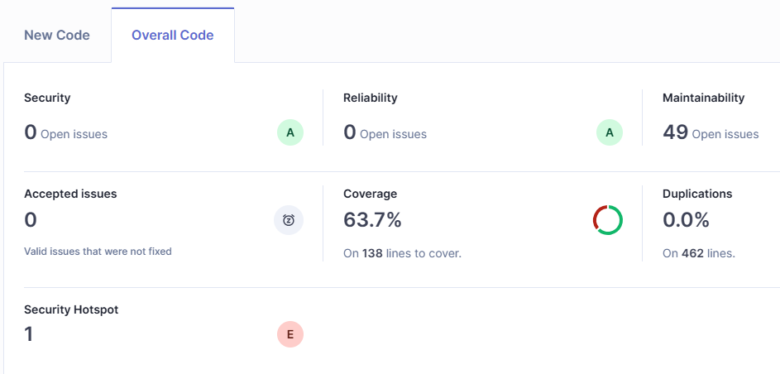
- What was found in the analysis (copy the dashboard)? Explore the analysis dashboard and explain the results that you obtained for your project.
- Has your project passed the defined quality gate? Elaborate on your answer (in the Readme).
- In the configuration of Sonar, you can see references to external tools such as Checkstyle, PMD and SpotBugs related to Java analysis (no need for changes). What are they?

Note: SonarQube is available as a plugin for VS Code and IntelliJ

Technical debt
Let’s analyze a Spring Boot project with web endpoints. Make a copy of the project from Lab 3.4 (meals booking with REST API). Be sure you are using a project with JUnit tests implemented and passing.
- Default Spring Boot configuration does not include the JaCoCo plugin by default and the coverage information will not be picked up by Sonar.
Be sure that you have tests in the project and the JaCoCo plugin configure in the Maven build (use an updated plugin version).
- Analyze this project with SonarQube.
Remember to create a new project in your Sonar instance.
- Take note of the technical debt found (Measures > Overview, Maintainability). Explain the reported values.
- Discuss the coverage values on the SonarQube dashboard (how many lines are “not covered”? And how many conditions? Are these values good?)
- Be sure to introduce changes in your code.
- Analyze the reported problems and be sure to correct the severe code smells reported (critical and major).
- Add some additional API endpoints.
Update (rerun) the analysis.
- Check the current conditions of the quality gate being applied (top bar > Quality Gates).
Create a new Quality Gate configuration by combining a set of criteria. Make the “no issues” rule on new code more flexible (not a best practice).
Explain your mix of metrics.

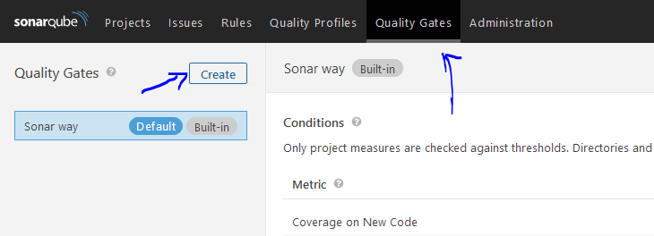
- Add some new code to the project and be sure to provide appropriate coverage.
You should run the analysis and have the Quality Gate for new code passing.

Frontend inspection (performance, accessibility & best practices)
We’ll use a sample QuickPizza website (deployed in a container) providing a recommendation feature along with a basic API.
- Clone the repository k6-oss-workshop and run the playground (note: this example discusses performance metrics and tools, which we won’t use for this exercise).
$ cd k6-oss-workshop && docker compose up -d

Consider the QuickPizza website running locally (e.g., http://127.0.0.1:3333). We wany to audit the frontend, not only for performance, but also considering other quality aspects, such as accessibility.
- Install “lighthouse” CLI tool (using NodeJS’ package manager).
npm install -g lighthouse
- use the lighthouse to audit our target site (lighthouse uses Chrome DevTools Protocol to assess the browser, so it expects Chrome/Chromium available; if not possible, consider the approach in d):
lighthouse --view http://127.0.0.1:3333
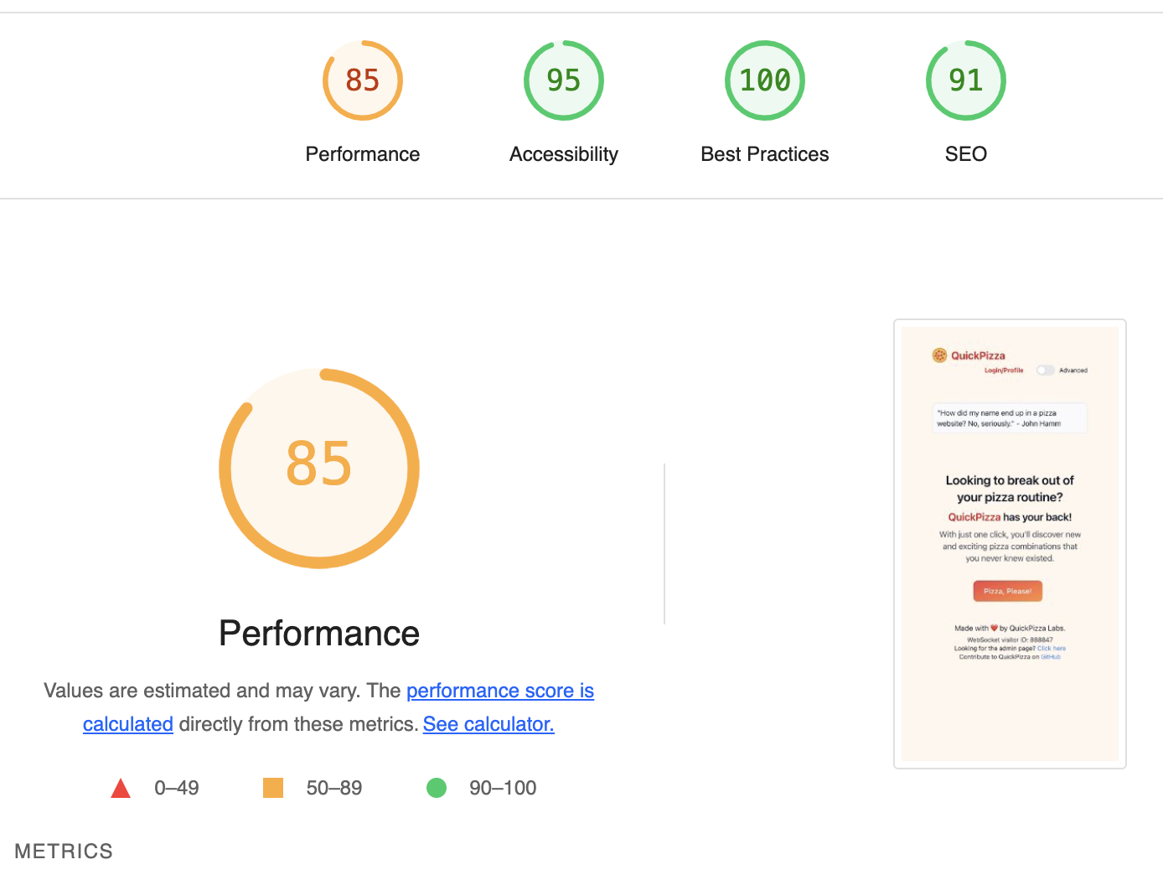
- Analyze the results report and try to answer the following questions:
- What metrics are contributing the most to the frontend perceived performance? What do they mean?
- How would you make the site more accessible?
- Use the Chrome/Chromium browser and open the Developer Tools, namely the “lighthouse” tab. Perform the analysis for the same site and compare with the previous results. Use an incognito tab (why?).
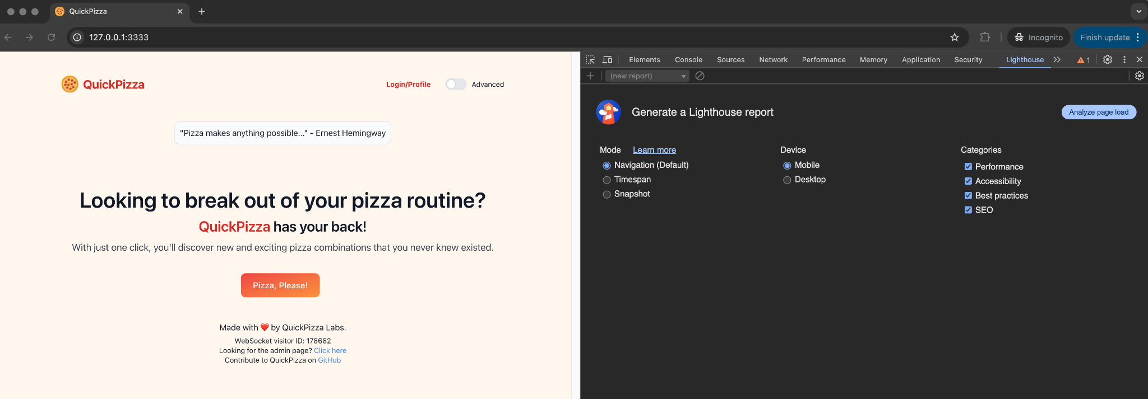
- Using the embed Lighthouse tool in Chrome, make the analysis considering a desktop device. Are the results the same as the previous ones or are they different? Why?
- Consider some well-known website (e.g., https://www.ua.pt or maybe one application developed by yourself) and analyze it using lighthouse. What are the main problems, and which are their impact?
How does this kind of inspections relate to Quality Assurance practices?

AI-assisted reviews
In this activity, you are expected to use some artificially intelligence engine specialized in coding.
- If possible, configure GitHub Copilot extension in your IDE; otherwise, you can use an interactive webpage with another engine (Phind,…).
- Use a previous project from the Labs. Of, if you prefer, you can use this sample project (buser), also implemented by students.
- You want code to be clean, easy to understand and maintain, and open to future changes.
Ask Copilot to review specific classes in the code.
Document the AI “collaboration”: which prompt strategy did you use? Which points/changes did you find relevant/interesting from the AI suggestions? Which refactoring would you effectively recommend to include in production?
Try to refer to the suggested refactoring practices using their “well-known” names in code refactoring catalogs (e.g.: “Replace Magic Numbers”).
- In the previous activity, you have used the AI tool to help you clean the code. Try the opposite direction (for pedagogical purposes only…), i.e., work with the AI tool to introduce “anti-patterns”, e.g.: insert a few examples that would need the refactoring practices in the above catalog.
Discuss the (new) “bad smells”.

If you use the help of an AI assistant, it may be the case the new code will be already “clean”. You may wish to insert “bad smells” on purpose.
A more detailed version of the refactoring methods catalogue can be found in Fowler book.

